White Paper Title

Author, Date

Awesome picture (or company logo) here

# Introduction

Introduce the purpose of your white paper analysis here. The white paper format is meant to be a concise document, so keep the page count to 4 pages or fewer.

# Problem Statement

Succinctly describe the problem you are solving.

# Background

Discuss important background info and research here.

# Solution

Discuss your solution and results. Figures should be labeled as shown below by inserting a caption and referencing the figure caption in the text like this (Figure 1). In Word, you can click the “References” tab, then click “Cross-reference” under the captions section at the top to reference a numbered figure. Google Docs doesn’t seem to have a similar feature that auto-links references, but figures can be manually captioned and labeled.

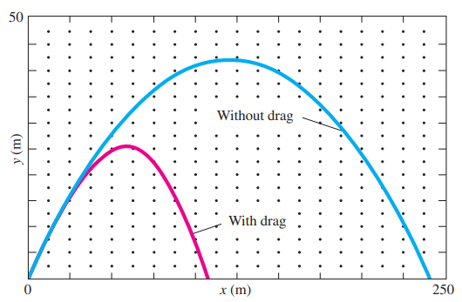

Figure 1: Example figure caption describing the figure that should be references in the body text.

# Conclusion

Briefly discuss your overall conclusion from your research, solution and analysis here.

# References

Cite any references you used in your paper here using a standard MLA citation format.